About Me
Let me introduce myself, I am a Graphic designer having
7 years experience in this job. I am very experienced in the f ield of graphic designers such as photography, video editing, layouting and copywriting.

Helene Paquet

Education
2018 - 2020 2018 - 2020
Larana Animation School Larana Animation School

G r a p h i c D e s i g n e r

Contact
Bachelor's Degree in Multimedia Arts
Member of the Design Club

Work Experience
Bachelor's Degree in Multimedia Arts
Member of the Design Club

+123-456-7890

hello@reallygreatsite.com www.reallygreatsite.com
123 Anywhere St., Any City, ST 12345

Pro Skills

I l lustration Drawing

2020
-

2022

2020

- 02
2 2

2020

- 02
2 2
Victory Film Studio Production

Senior Graphic Designer
Creating landing pages for various websites
Working on brand new Trend of Graphic Design

Victory Film Studio Production

Senior Graphic Designer
Creating landing pages for various websites
Working on brand new Trend of Graphic Design

Victory Film Studio Production

Senior Graphic Designer
Creating landing pages for various websites
Working on brand new Trend of Graphic Design

Teamwork

Creative Mind
References

Juliana Silva Howard Ong

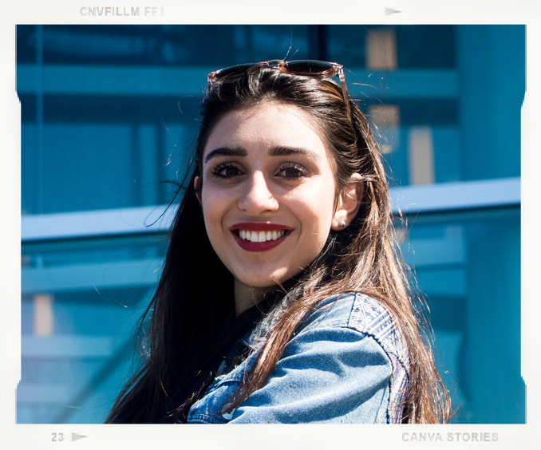Leadership

Videography
Wardiere Inc. / CEO
+123-456-7890
Wardiere Inc. / CEO
+123-456-7890

